**RF BASED CHEMICAL INDUSTRY MONITORING AND CONTROLLING SYSTEM**

***Ch. Tagore Rishil - 19951A04J4***

***Vamshi Kareti – 20955A0420***

***Chandra Vivek - 20955A0423***

**RF BASED CHEMICAL INDUSTRY MONITORING AND CONTROLLING SYSTEM**

***A Project Report***

***Submitted in partial fulfilment of the***

***Requirements for the award of the degree of***

**Bachelor of Technology**

**in**

**Electronics and Communication Engineering**

***By***

**Ch. Tagore Rishil - 19951A04J4**

**Vamshi Kareti – 20955A0420**

**Chandra Vivek – 20955A0423**

**Under the supervision of**

**Dr. V. Padmanabha Reddy**

**Professor of ECE**



**Department of Electronics and Communication Engineering**

**INSTITUTE OF AERONAUTICAL ENGINEERING**

**(Autonomous)**

**Dundigal, Hyderabad – 500 043, Telangana**

May, 2023

© 2023, Ch. Tagore Rishil , Vamshi Kareti , Chandra Vivek . All rights reserved.

# DECLARATION

We certify that

a. The work contained in this report is original and has been done by me under the guidance of my supervisor(s).

b. The work has not been submitted to any other Institute for any degree or diploma.

c. I have followed the guidelines provided by the Institute in preparing the report.

d. I have conformed to the norms and guidelines given in the Ethical Code of Conduct of the Institute.

e. Whenever I have used materials (data, theoretical analysis, figures, and text) from other sources, I have given due credit to them by citing them in the text of the report and giving their details in the references. Further, I have taken permission from the copyright to owners of the sources whenever necessary.

**Place: Hyderabad Signature of student:**

**Date:**

**19951A04J4**

**20955A0420**

**20955A0423**

# 

# CERTIFICATE

This is to certify that the project report entitled **RF based chemical industry monitoring and controlling system** submitted by **Mr. Ch. Tagore Rishil , Mr. Vamshi Kareti ,** **Mr. Chandra Vivek** to the Institute of Aeronautical Engineering, Hyderabad in partial fulfillment of the requirements for the award of the Degree Bachelor of Technology in Branch **Electronics and Communication Engineering** is a bonafide record of work carried out by him/her under my/our guidance and supervision. The contents of this report, in full or in parts, have not been submitted to any other Institute for the award of any Degree.

**Supervisor Head of the Department**

**Dr. V. Padmanabha Reddy Dr. P. Munaswamy**

**Professor**

**Date:**

# APPROVAL SHEET

This project report entitled **RF based chemical industry monitoring and controlling system** by **Mr. Ch. Tagore Rishil ,** **Mr. Vamshi Kareti** , **Mr. Chandra Vivek,** is approved for the award of the Degree Bachelor of Technology in Branch **Electronics and Communication Engineering.**

**Examiner(s) Supervisor**

**Dr. V. Padmanabha Reddy**

**Professor**

**Principal**

**Dr. L.V. Narasimha Prasad**

**Date:**

**Place:**

# ACKNOWLEDGEMENT

I wish to take this opportunity to express our deep gratitude to all those who helped, encouraged, motivated and have extended their cooperation in various ways during our project work. It is my pleasure to acknowledge the help of all those individuals responsible for foreseeing the successful completion of our project.

I want to thank my project guide **Dr. V. PADMANABHA REDDY**, Professor of ECE and express my gratitude to **Dr. P. MUNASWAMY**, Head of the Department with great admiration and respect to for their valuable advice and help throughout the development of this project by proving with required information without whose guidance, cooperation and encouragement, this project couldn’t have been materialized.

And special thanks to my friends for helping me develop this project. Last but not least, I would like to thank my principal**, Dr. L.V. NARASIMHA PRASAD,** and Management, for extending his help in all circumstances.

# ABSTRACT

The industry has demonstrated tremendous interest in intelligent wireless sensor-based controls because they provide cost-effective solutions, increased power management, simple maintenance, and flexible deployment in distant and inaccessible places. These are being used effectively in a variety of industrial applications, such as maintenance, surveillance, management, and protection The emphasis of the discussion is on research that solves the challenges measurement systems encounter in factories. It also offers a design solution to handle the problems these applications confront. The objective of the Smart Interface introduced in this text is to design a versatile platform capable of accommodating the hardware interface, payload, and communication needs of diverse sensors, motors, and instrumentation systems. The system utilizes radio frequency (RF) communication to transmit data between the transmitter and receiver units. The system is designed to provide accurate and reliable data for detecting various parameters such as gas leaks, fires, magnetic fields, and changes in the liquid level. The collected data is analysed, and the system can take necessary actions in case of any deviations from the predefined ranges. The system offers a significant advantage in terms of safety, efficiency, and cost-effectiveness, making it a viable solution for chemical industry monitoring and control. The RF-based chemical industry monitoring and controlling system is a promising technology that has the potential to revolutionize the chemical industry and enhance its sustainability.

**Keywords:** Wireless Sensor Networks, RF module, Sensor Platform, Real-Time Monitoring, Internet of Things (IoT).

# Table of Contents

DECLARATION iii

CERTIFICATE iv

APPROVAL SHEET v

ACKNOWLEDGEMENT vi

ABSTRACT vii

Table of Contents viii

List of Figures x

List of Tables xii

List of Abbreviations xiii

Introduction 1

1.1 Introductory Remarks 1

1.2 Embedded System 2

1.2.1 Building Blocks of Embedded System 2

1.3 Internet of Things 3

1.4 Objectives 3

1.5 Outcomes 3

1.6 Organization of the Thesis 4

Literature Survey 5

2.1 Introductory Remarks 5

2.2 The Findings 5

2.3 Research gap 8

2.4 Problem Identification 8

Methodology 10

3.1 Introduction 10

3.2 Existing Method 10

3.2.1 Block Diagram 10

3.2.2 Microcontroller 11

3.2.3 TEMPERATURE SENSOR 11

3.2.4 ZIGBEE TECHNOLOGY 13

3.2.5 LCD (Liquid Crystal Display) 14

Implementation 16

4.1 Introduction 16

4.2 Transmitter 16

4.2.1 POWER SUPPLY 16

4.2.2 EL4N35 OPTOCOUPLER IC 20

4.2.3 Schmitt Trigger 22

4.2.4 FIRE SENSOR 24

4.2.5 REED RELAY-FIELD SENSOR 25

4.2.6 FLOATING SENSOR – OIL SENSOR 27

4.2.7 MQ2 Gas Sensor 28

4.2.8 HT12E RF ENCODER IC 30

4.2.9 RF TRANSMITTER 31

4.3 Receiver 32

4.3.1 RF RECEIVER MODULE 32

4.3.2 HT12D RF Decoder IC 33

4.3.3 Relay module 34

4.3.4 Transistor Relay Driver 35

Results 36

Conclusion and Future Scope 40

6.1 Conclusion 40

6.2 Future Scope 40

References 41

# List of Figures

Figure1.1 Block Diagram of Embedded System 2

Figure 3.1 Block Diagram of Existing Method 10

Figure 3.2 Pin diagram of Microcontroller 11

Figure 3.3 Temperature Sensor (LM35DT) 12

Figure 3.4 ZigBee 13

Figure 3.5 LCD (Liquid Crystal Display) 14

Figure 4.1 Block Diagram of Transmitter 16

Figure 4.2 Block diagram of power supply 17

Figure 4.3 Circuit diagram of center tapped full wave rectifier 17

Figure 4.4 voltage regulator 19

Figure 4.5 4N35 Pinout 20

Figure 4.6 Working of optocoupler...............................................................................21

Figure 4.7 Schmitt Trigger using IC 555 22

Figure 4.8 Waveforms of Schmitt trigger 23

Figure 4.9 IR Infrared Flame Module Pin Diagram 24

Figure 4.10 REED RELAY-FIELD SENSOR 25

Figure 4.11 FLOATING SENSOR 27

Figure 4.12 MQ-2 Sensor 28

Figure 4.13 Pinout diagram of HT12E RF ENCODER IC 30

Figure 4.14 RF TRANSMITTER 31

Figure 4.15 Block diagram of receiver 32

Figure 4.16 RF RECEIVER MODULE 32

Figure 4.17 Pinout diagram of RF decoder IC 33

Figure 4.18 Basic Relay Module 34

Figure 4.19 Circuit Diagram of Relay Module 35

Figure 4.20 Circuit Diagram of Transistor Relay Driver 35

Figure 5.1 Transmitter Circuit 36

Figure 5.2 Receiver Circuit 37

Figure 5.3 Gas Detection 37

Figure 5.4 Magnetic Field 38

Figure 5.5 Oil Detection 38

Figure 5.6 Heat Detection 39

# List of Tables

Table 4.1 Pin description of Voltage regulator 19

Table 4.2 Pin description of Flame Sensor Module 24

Table 4.3 Flame Sensor module Specifications 25

Table 4.4 Pin description of MQ-2 Sensor 29

# List of Abbreviations

|  |  |  |  |  |  |  |  |  |  |  |  |  |  |  |  |  |  |  |  |
| --- | --- | --- | --- | --- | --- | --- | --- | --- | --- | --- | --- | --- | --- | --- | --- | --- | --- | --- | --- |
| |  |  | | --- | --- | | **IOT** | Internet of Things | | **SPI** | Serial Peripheral Interface | | **PIC** | Peripheral Interface Controller | | **GUI** | Graphical User Interface | | **USB** | Universal Serial Bus | | **LCD** | Liquid-Crystal Display | | **TTL** | Transistor-transistor logic | | **CMOS** | Complementary Metal Oxide Semiconductor | | **WSN**  **RTOS** | Wireless Sensor Network  Real Time Operating System | |  |
|  |  |
|  |  |
|  |  |
|  |  |
|  |  |
|  |  |
|  |  |
|  |  |
|  |  |
|  |  |

# Chapter 1

# Introduction

## 1.1 Introductory Remarks

This research paper aims to explore the regulation of safety systems in the chemical industry through the implementation of wireless sensor system configurations for monitoring and controlling a number of physical parameters. The proposed system will allow parameter data to be transferred between a transmitter unit and receiver unit by wireless transfer. The transmitter unit comprises components such as Gas Sensor, Flame Sensor, Floating Sensor, Reed Relay, HT12E Encoder, and an RF Transmitter Module. The receiver unit includes components such as RF Receiver Module, HT12D Decoder, Signal Buffer, Relays, and loads. RF-based systems offer numerous advantages including extended range, high data transfer rates, low power consumption, cost-effectiveness, and enhanced security.

Our objective is to create a system capable of monitoring sensor data and making critical industrial decisions. Currently, available systems primarily focus on monitoring equipment and notifying authorized personnel when any issues arise, requiring manual intervention and physical presence. With this in mind, we have developed a system that can monitor parameters within an industrial setting and autonomously take necessary control actions.

Effective communication is vital in any economic control and monitoring system. However, wired communication systems can become complex due to wiring and other configurations. In contrast, wireless systems have proven to be advantageous in reducing these complexities. Therefore, we have developed a cost-effective solution by utilizing RF (Radio Frequency) technology. RF technology addresses the significant challenges faced by other wireless communication systems. Thus, our proposed RF-based monitoring and controlling system for the chemical industry offers significant benefits in terms of safety, efficiency, and affordability, making it a viable option for monitoring and controlling chemical industry operations.

## 1.2 Embedded System

A system is a structure in which all of its parts work together according to a set of rules. It can also be described as a way to complete one or more tasks according to a set schedule. One example of a device that shows the time is a watch. Its components adhere to a set of rules in order to display time. If one of the watch's components fails, it won't work. Consequently, the many parts of a system are interdependent.

An embedded system refers to a computer system where software is seamlessly integrated into the hardware, resulting in a customized solution for a specific application, product, or component of a larger system. Embedded systems can range from extensive integrated systems to compact standalone units. A microcontroller-based control system is utilized to perform a specific task within such embedded systems.

The term "hardware" refers to the tangible component of an embedded system that is physically attached to an embedded system. It has a power supply, an LCD display, an integrated circuit with a microprocessor, and other components. Application software allows users to perform various tasks on an embedded system by modifying the existing code. The real-time operating system (RTOS) provides an important part of functioning of an embedded system. It manages the scheduling of the CPU's execution to minimize latencies and acts as a bridge between application software and hardware.

## 1.2.1 Building Blocks of Embedded System

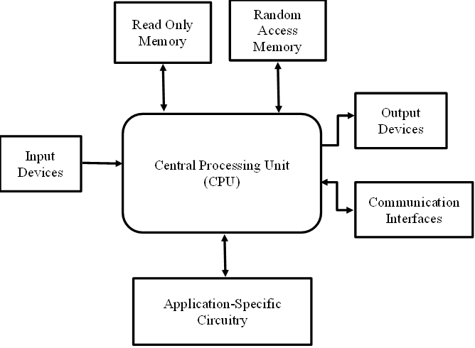

### Figure1.1 Block Diagram of Embedded System

The fundamental components of an embedded system are depicted in Figure 1.1. These components include RAM, ROM, input and output devices, AISC, and communication interfaces that are connected to a central processing unit. All the information that the machine's processor is presently working with is retained in RAM, also called random access memory. Considering information stored within flash memory can often be used significantly more swiftly than on an HDD, a solid-state, or similar permanent hard drive, size is critical for system performance.

A type of computer storage known as read-only memory (ROM) consists of permanent, non-volatile data that can typically only be read from an input/output (IO) device refers to any hardware component that enables human operators or other systems to interact with a computer. These gadgets make it easier for data to be sent from a desktop or laptop to a device and to be received from a device to a computer.

## 1.3 Internet of Things

Internet of Things stands for the connectedness of physical items that have electronics built into them, allowing for communication and interaction between them as well as with their surroundings. This technology has the potential to revolutionize daily life by offering enhanced levels of service. The IoT has already made significant advancements in various sectors, such as healthcare, energy, genetic therapies, agriculture, smart cities, and intelligent homes.

The Internet of Things is an interconnected system of computer tools that are integrated into everyday things and enable them to exchange data with one another.

## 1.4 Objectives

The main objectives of this study are:

* To create and execute wireless sensor networks.
* To monitor the activities in the industry such as liquid levels, temperature, field and control parameters like gas leakage of the surroundings remotely.

## 1.5 Outcomes

The final model will be able to:

* To improve the standards of safety systems in the industry.
* To design a remote monitoring system with long range of communication, good reliability and low cost.

## 1.6 Organization of the Thesis

The current investigation is meticulously detailed in six chapters. A succinct representation is provided below.

**Chapter 2:** A brief review on the previous studies and their findings were presented as a literature survey.

**Chapter 3:** The third chapter gives a detailed description of the previous existing method which is based on microcontroller and ZigBee.

**Chapter 4:** The implementation of the proposed method along with its experimental setup has been shown in a detailed manner. Also, the description of the components used has also been explained.

**Chapter 5:** The experimental results that are obtained by connecting various sensors and remote monitoring is shown in this section.

**Chapter 6:** The detailed conclusion of the work is written along with the future research possibilities in this area.

### Summary

In this section, why wireless sensor networks are used as the base technology is clarified. Described brief introduction about the devices used clearly. Explains about the technologies used to design the system to monitor the parameters wirelessly using, RF, sensors, and controller.

# Chapter 2

# Literature Survey

## 2.1 Introductory Remarks

The major purpose of this written study is to provide a preview of the available literature on previous studies in an effort to quantify the current state of research. This section provides a general overview of previous research on the various experiments and investigations that are discussed in the sections that follow.

## 2.2 The Findings

H. Ramamurthy, B. S. Prabhu, R. Gadh, and A. M. Madni have proposed a stage for wireless smart sensors intended for predictive maintenance and instrumentation systems. The study involved conducting experiments to analyze performance indicators such as bandwidth, network latency, and packet bursts under varying conditions. The findings indicate that for Bluetooth, increasing distance leads to larger and more irregular delays, while traffic has minimal impact. Additionally, performance degrades with an increased number of packets per burst. On the other hand, for Wi-Fi, performance deteriorates with distance as delays become irregular, and traffic has a more pronounced effect, particularly at larger distances. Moreover, Wi-Fi demonstrates improved performance for transmitting larger payloads due to consistent channel access time. In summary, Bluetooth is more suitable for industrial applications that require real-time delivery of limited data bursts in noisy environments, while Wi-Fi is better suited for scenarios involving the transmission of large data volumes in less noisy environments. [1]

P. V. Shekdar and S. R. Hirekhan introduced a smart sensor platform with the objective of designing a versatile hardware interface capable of accommodating various actuators and sensors. Additionally, In order to support real-time applications like industrial monitoring and control, a centralized data processing infrastructure was also created. The proposed system contains a network of sensors communicating through a centralized control unit utilizing conventional RF communications. Wireless connection and a Serial Peripheral Interface are used in the implementation to successfully connect various sensors to the smart sensor interface unit. Experimental results demonstrate the feasibility of establishing a real-time system using the smart sensor nodes. Furthermore, the use of an Aurdino microcontroller that is SPI compatible decreases the requirement for external ADCs. The wireless RF module allows for wireless communication with a maximum line-of-sight range of 30 meters. [2]

The researchers Ramamurthy, Prabhu, Gadh, and Madni conducted experiments that demonstrated the feasibility of establishing a sustained near-real-time technology using the smart sensor nodes (SSNs). The adaptability of smart sensor interface (SSI) allows for the implementation of various applications. In terms of power and performance, ZigBee proves to be a superior alternative to Bluetooth and RFID due to its strong low-power capabilities. The implementation of ZigBee support is currently underway, and separate reports will be provided. For applications like store-and-forward systems and cold chain monitoring, a long-distance wireless connection with network coverage over the whole working area is required. GPRS (General Packet Radio Service) is considered a suitable option due to its long-distance and broad-area connection with sufficient capacity. The addition of GPRS support will also be reported separately. [3]

A two-part system designed by S. R. Khan and M. S. Bhat consists of a GUI system for controlling, monitoring, and development and interfacing of microcontroller hardware. The system utilizes a central controller, specifically the 18 series PIC microcontroller 18F2550, which is connected to a PC via USB. The controller interfaces with a DC motor, temperature and humidity sensor, and other industrial machines. The system is managed through a Visual Basic-based GUI that enables temperature and humidity sensing, control of three machines or devices, and operation of the DC motor. The system is intended for specialized industrial applications. Through USB connectivity, the controller enables PC-based control of the motor speed and monitoring of numerous sensor metrics. This designed system can be deployed in different industrial equipment, and multiple machines can be easily managed. The Visual Basic-based GUI allows for the creation of an installation file, enabling its usage on any PC. The USB interface ensures convenient plug-and-play functionality. [4]

P. Karemore and P. P. Jagtap have developed a system utilizing Raspberry Pi for the purpose of controlling and monitoring an industrial workshop. This system employs an IoT-based framework and is responsible for managing the lighting and fans, as well as monitoring environmental parameters such as gas levels and temperature. The workshop's environmental data can be accessed through a web browser interface. Additionally, the system includes the monitoring of voltage and current readings from a cutting tool. It provides alerts to change the blade if its deviation exceeds the predefined threshold value. To control various appliances, the proposed system utilizes commands sent through SMS using a GSM module. Another Raspberry Pi-based system has been designed for industrial automation. It focuses on monitoring parameters such as gas, and temperature. The system utilizes a mobile application and a web page for load control. Furthermore, the system incorporates a feature to send logged data to a centralized cloud server. The objective is to ensure a safe working environment for the workers. To prevent network intrusion, a logging system based on facial recognition has been implemented. [5]

Aishwarya Khandekar, Meenakshi Basvankar, and Alfarin Sayed have presented a paper focusing on the remote monitoring and control of industrial appliances, particularly when the user is not physically present at the location. The central component of this project is a microcontroller. The main objective is to minimize accidents and human errors by implementing an automated system that enhances safety in industrial environments. The proposed system utilizes sensors to detect factors such as smoke, temperature, and fire in order to prevent accidents. It is designed to control various loads, including cooling fans, exhaust fans, and water sprinklers, based on the detected conditions. Additionally, the system provides information about the detected events to a supervisor through an LCD display. The paper involves the study of wide range of electronic devices integrated with sensors. The final product aims for a user-friendly and simplistic design to facilitate easy interaction, considering the diverse technical knowledge present in industrial settings. [6]

B. Razavi has proposed an article that presents an RF transmitter architecture specifically designed for wireless applications. The article provides an overview of constant- and variable-envelope modulation techniques and discusses the RF interface and power antenna interface in a general context. After discussing the design challenges associated with transmitter layouts, the article delves into the design of up-conversion mixers and power amplifiers. Emphasizing high levels of integration, the paper offers a comprehensive review of RF transmitter design for wireless systems. It begins with an exploration of general transmitter design challenges and modulation techniques, before narrowing its focus to mobile units. [7]

T. Ramachandran, S. Kumar, A. Kumar, and R. Agarwal have introduced a technology for controlling home appliances using RF-based device control. The system utilizes a Microcontroller AT89C51 for programming and device control. The implemented design features a Wireless RF Based Device Control module, which incorporates a basic RF monitoring circuit allowing for remote control primarily through RF mode. The RF remote control offers the advantage of a sufficient range of up to 200 meters when equipped with appropriate antennae, and it is also directional. In contrast, an IR remote has a range of approximately five meters and requires precise orientation towards the receiver module. The proposed technology has the potential to control additional appliances, serving as a basis for future enhancements and expansion. [8]

## 2.3 Research gap

From the survey, it is clear that wireless remote sensing has been achieved by using Bluetooth module or a ZigBee module which offers short range of communication with more power consumption. Moreover, there hasn’t developed a reliable system that monitors multiple parameters remotely over long distances.

## 2.4 Problem Identification

The existing method uses a microcontroller, ZigBee module, and a temperature sensor. This system is limited to monitor only the temperature parameter remotely over a short range. Moreover, the existing circuit consumes more power and the system is not highly secured. The following drawbacks are resolved by using RF module which provides a greater range of communication with low power consumption and high security.

**Summary**

From the above literature review, it has been noticed that, an extensive research work has been done on the trends of the RF technology and the implementation of wireless systems for industrial automation and controlling.

# Chapter 3

# Methodology

## 3.1 Introduction

Humans cannot operate loads simultaneously in industries. This paper presents a method for improving load management in industries by integrating ZigBee and microcontroller technologies. The system utilizes ZigBee wireless technology to enable remote monitoring and enhance existing industrial monitoring practices. Various sensors are used to monitor critical industrial factors such as current, voltage, temperature, and so on. If any issues are detected with the loads, they are automatically disconnected, and relevant information is transmitted to the server via ZigBee communication. The proposed approach aims to enhance industrial monitoring standards and efficiently address load-related challenges using rapid technologies.

## 3.2 Existing Method

Figure 3.1 describes the architecture of the industry monitoring system which is being used for temperature sensor and the main unit is the microcontroller. This module is connected to the ZigBee for the wireless transfer of data for monitoring and controlling. The output can be seen in a 16x2 LCD display. The main power supply for the whole system is an AC to DC Regulated power supply. The relay circuit is allowing only small amount of electrical current to control high current loads.

## 3.2.1 Block Diagram

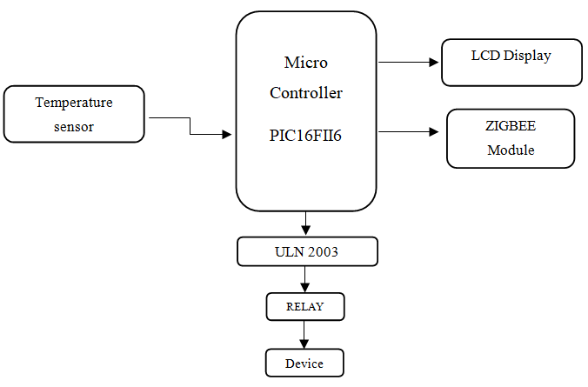

### Figure 3.1 Block Diagram of Existing Method

## 3.2.2 Microcontroller

A microcontroller, also known as an MCU, is a specialized computer chip designed to control electronic devices. It differs from general-purpose microprocessors used in personal computers as it aims to achieve self-sufficiency and cost-effectiveness. Unlike general-purpose microprocessors, which require additional chips to perform specific functions, microcontrollers are equipped with integrated memory and interfaces tailored for specific applications. In summary, a microcontroller serves as a compact computer-on-a-chip that provides control and functionality for electronic devices in a self-contained and cost-efficient manner.

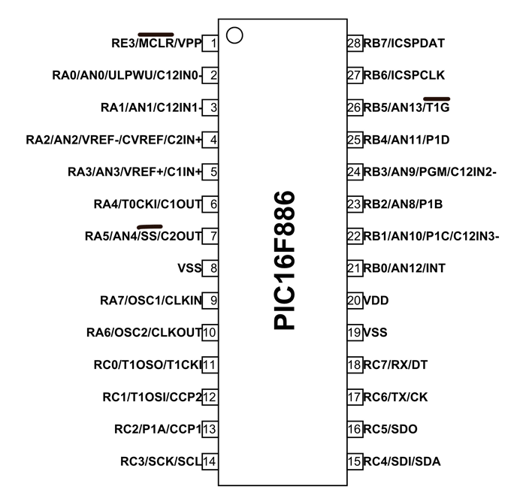

### Figure 3.1 Pin diagram of Microcontroller

(Source: https://embedjournal.com/printable-pic-18f-pin-diagram-for-rapid- prototyping/)

## 3.2.3 TEMPERATURE SENSOR

Figure 3.3 describe about the Temperature sensor. It is an electrical gadget made to precisely measure an object's or an environment's temperature. It is used for a variety of tasks, including measuring the temperature of industrial operations and keeping track of a room's temperature. A temperature sensor works on the premise that materials' electrical characteristics alter with temperature.

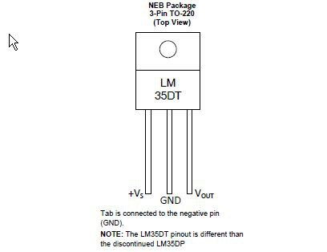

### Figure 3.3 Temperature Sensor (LM35DT)

**(**Source: https://smarttronik.com/en/temperature-sensor/4185-lm35dt-lm35-to-220-precision-temperature-sensor.html**)**

**LM35 Sensor Features**

* Input voltage range: 35V (maximum), -2V (minimum), typically 5V.
* Temperature measurement range: -55°C to 150°C.
* Accuracy: ±0.5°C.
* Low drain current: under 60uA.
* Affordable price.
* Suitable for remote applications due to its small size.
* Available in the TO-92, TO-220, TO-CAN, and SOIC packaging types.

**LM35 Temperature Sensor Applications**

* Determining the temperature in a particular environment.
* Incorporating thermal shutdown feature in a circuit or component.
* Checking the battery's temperature.
* Temperature measurement for HVAC (Heating, Ventilation, and Air Conditioning) applications.

## 3.2.4 ZIGBEE TECHNOLOGY

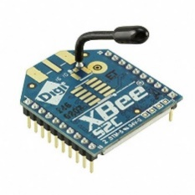

### Figure 3.4 ZigBee

(Source: https://www.amazon.in/XBee-ZigBee-Module-6-3mw-Antenna/dp/B0714LJY6Q)

Figure 3.4 Shows the ZigBee is a home networking technology and a standard developed by the ZigBee Alliance. It is designed for network control and sensing purposes, specifically as a personal area network within the low-rate task group 4 of IEEE 802.15.4.

ZigBee is a wireless communication standard that focuses on providing affordable and energy-efficient solutions for short-range wireless communication. It is specifically designed for low-power devices with low data rate requirements.

**General characteristics of ZigBee Standard**

* Efficient power usage with low power consumption.
* Suitable for transmitting data at low rates, typically between 20 to 250 kbps.
* Limited range of communication, typically covering distances of 75 to 100 meters.
* Quick network joining time of around 30 milliseconds.
* Capable of supporting both small and large networks, theoretically up to 65,000 devices and practically up to 240 devices.
* Cost-effective solution with affordable product and implementation costs, thanks to its open-source protocol.
* Utilizes extremely low duty cycle for conserving power.
* Operates across three frequency bands, offering a total of 27 channels for communication.

**ZigBee Applications:**

* Automation of the Home.
* Collection of medical data.
* Control systems for industrial applications.
* System for reading metres.

## 3.2.5 LCD (Liquid Crystal Display)

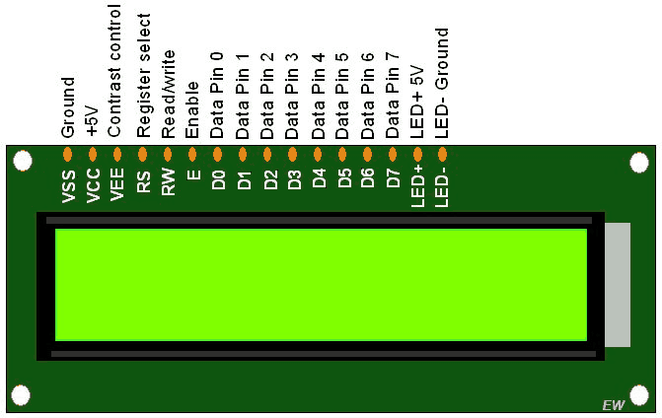

### Figure 3.5 LCD (Liquid Crystal Display)

(Source: https://www.electronicwings.com/arm7/lcd-16x2-interfacing-with-lpc2148-8-bit-mode)

Figure 3.5 shows a 16x2 LCD (Liquid Crystal Display) which is interfaced with the whole design to monitor the data.

**Features**

* The LCD operates within a voltage range of 4.7V to 5.3V.
* It is divided into two rows, each of which may show up to 16 characters.
* The LCD has a current consumption of 1mA when the backlight is not activated.
* Each character on the LCD can be represented by a 588-pixel box.
* It offers two modes of operation: 4-bit and 8-bit.
* The LCD includes a backlight with blue and green colors.
* It has the ability to display custom generated characters.

**Specifications**

* The voltage range for operating this display is between 4.7V and 5.3V.
* The bezel surrounding the display has dimensions of 72 x 25mm.
* The display operates at a current of 1 mA when the backlight is not activated.
* The dimensions of the module's printed circuit board (PCB) are 80L x 36W x 10H mm.
* It utilizes the HD44780 control unit.
* The backlight can be either green or blue, using LEDs.
* There are sixteen columns in total.
* The display consists of two rows.
* It is equipped with sixteen LCD pins.
* The display can accommodate up to 32 characters.
* It supports both 4-bit and 8-bit modes of operation.
* Each character on the display is composed of a pixel box with 58 pixels.
* The font size for each character measures 0.125 in width and 0.200 in height.

**Summary**

The method and its application to the existing model have been presented in detail in this section. We've also looked at each block individually and learned a little bit about how to use Zigbee modules and sensors to create wireless systems.

# Chapter 4

# Implementation

## 4.1 Introduction

RF based chemical industry monitoring and controlling system are proposed to monitor and control the parameters in the chemical industry for safety management. The system has a wide range of sensors like MQ2 for detecting gases like propane, Hydrogen and a flame sensor to detect fire and a floating sensor to monitor the level of liquids, and a Reed relay to detect field. All the sensors are mounted on the transmission section and the outputs of sensors are displayed on the receiver section. The RF module is used to conduct interactions between the receiver and the transmitter units.

## 4.2 Transmitter

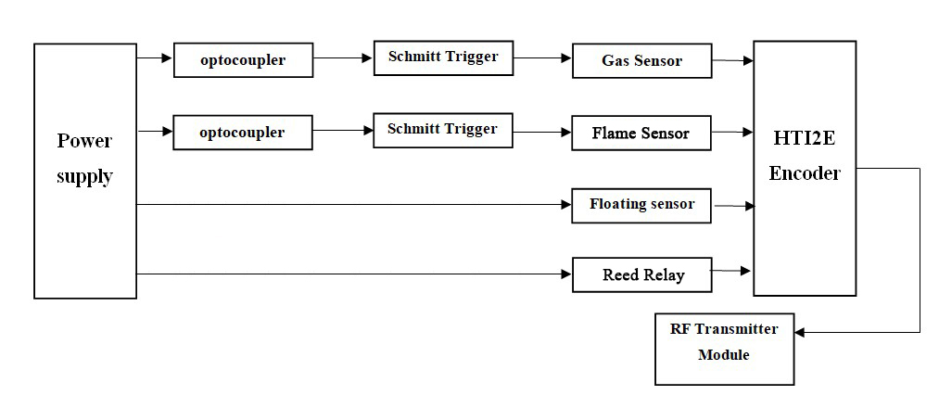

### Figure 4.1 Block Diagram of Transmitter

Figure 4.1 describes the blocks that are mainly involved in the methodology which is from the proposed model. The following sections will give a detailed description of the blocks.

## 4.2.1 POWER SUPPLY

As seen in Figure 4.2 a power source is an electrical device that supplies power to a load. A power supply is in charge of converting electrical power at a source into the voltage, current, and frequency needed to run a load. These devices, also known as electric power converters, can either be integrated into the appliances they supply power to or exist as separate units.

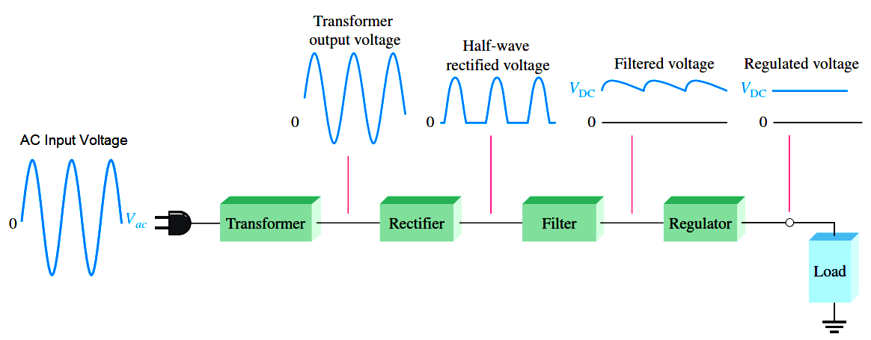

### Figure 4.2 Block diagram of power supply

**(**Source: https://instrumentationtools.com/basic-dc-power-supply-circuit/amp/)

**CENTER TAPPED FULL WAVE RECTIFIER**

Full-wave rectifier with centre tap, depicted in Figure 4.3, is a rectifier configuration that utilizes a full-wave rectifier with centre tap transformer and two diodes to convert the entire alternating current into direct current.

[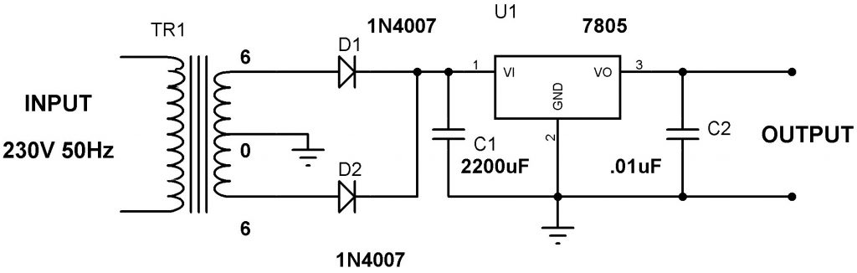](https://electrosome.com/wp-content/uploads/2013/05/5V-Power-Supply-Circuit-using-7805-Voltage-Regulator.jpg)

### Figure 4.3 Circuit diagram of center tapped full wave rectifier

(Source: https://electrosome.com/power-supply-design-5v-7805-voltage-regulator/amp/)

**Advantages and Disadvantages**

The**advantages of center-tapped FW**R include the following.

* Lower power loss.
* Reduced ripple factor in comparison to half-wave rectifier.
* Double the DC load current and DC output voltage compared to half-wave rectifier.
* When compared to a half-wave rectifier, this rectifier has double the rectification efficiency.

The center-tapped full wave rectifier disadvantages include the following.

* These are expensive.
* It is tough to set the secondary's centre for tapping.
* As PIV (peak inverse voltage) across every diode is twice the greatest voltage across the lower half of the minor winding, the diode used in the circuit should be able to withstand high PIV.

**Applications**

The **applications of center-tapped FWR** include the following.

* This rectifier is designed to convert high AC voltage to low DC voltage.
* Due to their high efficiency, these rectifiers are commonly utilized as fundamental elements in power supply units.
* They are employed to supply power to various devices such as motors, LEDs, and more.

**Voltage regulator**

Figure 4.4 depicts a voltage regulator. In circuits, voltage sources can vary, leading to variable output voltages. To address this, an integrated voltage-regulating network is used to keep the output voltage constant. The 7805 Regulator, part of the 78xx series of fixed linear voltage regulators, is a widely used integrated circuit that effectively handles such voltage fluctuations.

**7805 Voltage Regulator IC Specifications**

* The range of the input voltage is between 7V and 35V.
* The current rating is 1A.
* The Peak output voltage is 5.2V, while the minimum output voltage is 4.8V.

[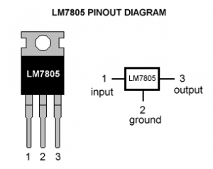](https://electrosome.com/wp-content/uploads/2013/05/Lm7805-pinout-diagram.gif)

### Figure 4.4 voltage regulator

(Source: https://www.hackatronic.com/5-volt-power-supply-using-lm-7805-ic/amp/)

# Table 4.1 Pin description of Voltage regulator

|  |  |  |  |
| --- | --- | --- | --- |
| Pin no | Pin | Function | Description |
| 1 | INPUT | Input Voltage | The IC pin in this voltage regulator receives a positive unregulated voltage for regulation. |
| 2 | GROUND | Ground | This pin serves as a ground connection, providing a common reference point for both the input and output of the circuit. |
| 3 | OUTPUT | Regulated output | This pin of the IC regulator is connected to the output terminal where the regulated 5V voltage is provided. |

**IC 7805 Voltage Regulator Applications**

7805 IC is used in a wide range of circuits. The major ones are:

* Regulator with a fixed output voltage.
* Negative voltage configuration using a positive voltage regulator.
* Regulator with adjustable output voltage.
* Current-regulating regulator.
* DC voltage-adjustable regulator.

## 4.2.2 EL4N35 OPTOCOUPLER IC

The 4N35 is a general-purpose optocoupler, as shown in Figure 4.6. It consists of a silicon NPN phototransistor and a gallium arsenide infrared LED. In order to prevent electrical interference, an optocoupler severs the connection that exists between the signal receiver and the signal source.

[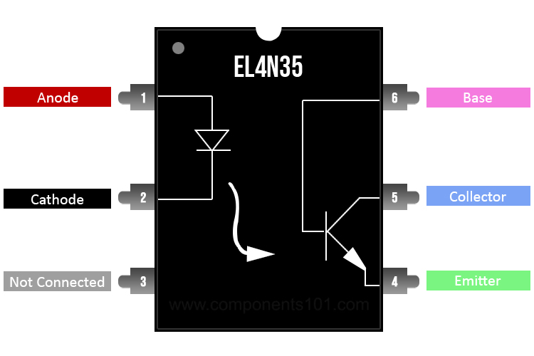](https://components101.com/sites/default/files/component_pin/EL4N35-Pinout.jpg)

### Figure 4.5 4N35 Pinout

(Source: https://components101.com/ics/el4n35-optocoupler-ic-pinout-datasheet-specifications)

The integrated circuit is available in a dual-inline package with six pins, as shown in Figure 4.5. To comprehend the IC's pin configuration, consult Table 4.2.

**Features and Specifications**

* It has a single channel.
* The maximum voltage across the collector and emitter is 30V.
* It can handle a forward current of 100mA.
* The forward voltage is 1.5V.
* The reverse voltage is 6V.
* The temperature range for operation is -55 to 100 degrees Celsius.

**Working of the Optocoupler IC**

The components of the optocoupler integrated circuit are shown in Figure 4.6 as a silicon NPN phototransistor and a gallium arsenide infrared LED. In addition, using it is a breeze. The base pin (pin 6) will not be required to use the IC as a phototransistor. Make your own circuit using the working circuit below to obtain the optocoupler IC.



### Figure 4.6 Working of optocoupler

(Source: https://components101.com/ics/el4n35-optocoupler-ic-pinout-datasheet-specifications)

To connect the infrared LEDs, connect pins 1 and 2 to the logic input and ground, respectively. The output device is linked to the other end of the collector pin (pin 5), which a resistor pulls up. The output is observed using an output probe. The fourth emitter pin should be connected to the ground. When the IR LED receives a logic 0 input, the transistor remains untriggered, resulting in a HIGH voltage across the collector-emitter terminal. When a logic 1 is received, the LED turns on, triggers the transistor, and creates a short circuit across the collector-emitter junction, resulting in a 0 at the output.

**Applications**

Below are several examples of the applications of the EL4N35 optocoupler IC:

* Circuits for driving relays.
* Feedback from a switch-mode power supply.
* Detection of alternating current mains.
* Isolation of the logic ground.

## 4.2.3 Schmitt Trigger

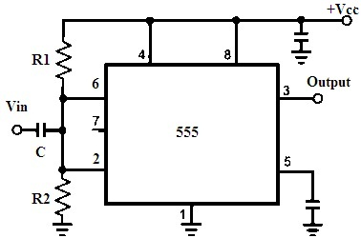

### Figure 4.7 Schmitt Trigger using IC 555

(Source: https://www.watelectronics.com/what-is-schmitt-trigger-circuit-its-working/)

The Schmitt trigger is depicted in Figure 4.7, and its configurations are listed below:

* This timer's supply (Vcc) pins are located on the 4 and 8 pins.
* A capacitor connects the two and six pins together, and this capacitor serves as the input.
* The resistors R1 and R2 in the voltage divider circuit facilitate this common point.
* The output will be high if the applied input is greater than the upper threshold value.
* The circuit's output is low if the applied input is less than the lower value of the od threshold.
* The value of the output is retained if the applied value falls within these upper and lower thresholds.
* This circuit's thresholds are 1/3 and 2/3 Vcc, respectively.
* The flip-flop will be Set or Reset based on the comparison with these thresholds, and the output states will change.
* Depending on whether the cycle is positive or negative, the flip-flops are set or reset when an input with an amplitude greater than Vcc/6 is applied.

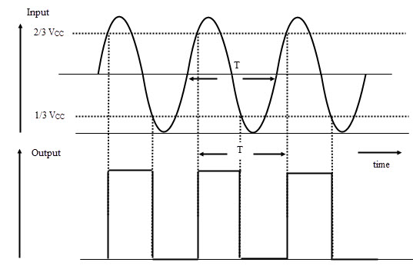

### Figure 4.8 Waveforms of Schmitt trigger

(Source: https://www.electronicshub.org/555-timer-as-schmitt-trigger/)

Figure 4.8 shows the output of the Schmitt trigger in waveforms using IC 555timer.

**Schmitt Trigger Applications**

Schmitt Trigger applications include

* These circuits are used to convert sine waves to square waves.
* It can be used as simple switches or as ON/OFF controllers.
* The negative feedback in these circuits closed-loop configurations can be used as Relaxation Oscillators, Function Generators, and power supply switching.
* Schmitt triggers are employed as level detectors.

## 4.2.4 FIRE SENSOR

## Figure 4.9 is a flame sensor module. It is a compact electronic device used to detect fires or bright light sources. It operates by detecting infrared (IR) light emissions from fires or light sources within the wavelength range of 760 to 1100 nm. The module incorporates a high-speed and sensitive YG1006 phototransistor sensor specifically designed for flame detection.

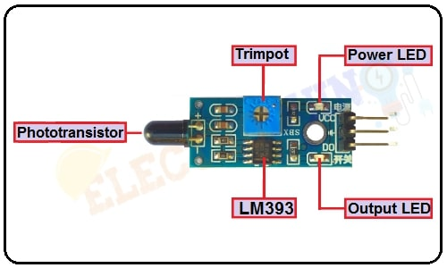

### Figure 4.9 IR Infrared Flame Module Pin Diagram

(Source: https://www.electroduino.com/ir-infrared-flame-sensor-module/)

# ****Table 4.2 Pin description of Flame Sensor Module****

|  |  |  |  |  |  |  |  |  |  |  |  |  |
| --- | --- | --- | --- | --- | --- | --- | --- | --- | --- | --- | --- | --- |
| |  |  |  | | --- | --- | --- | | **Pin Number** | **Pin Name** | **Description** | | 1 | **VCC** | +5 v power supply | | 2 | **GND** | Ground (-) power supply | | 3 | **OUT** | Digital Output (0 or 1) | |

# ****Table 4.3 Flame Sensor module Specifications****

|  |  |
| --- | --- |
| **Parameter** | **Value** |
| Operating Voltage | 3.3V – 5V |
| Operating Current | 15 mA |
| Sensor type | YG1006 Photo Transistor |
| Output type | Digital output / Digital and Analog output |
| Operating temperature | -25℃ ~ 85℃ |

**Applications**

* The detection of fire.
* Fire alarm Switches.

## 4.2.5 REED RELAY-FIELD SENSOR

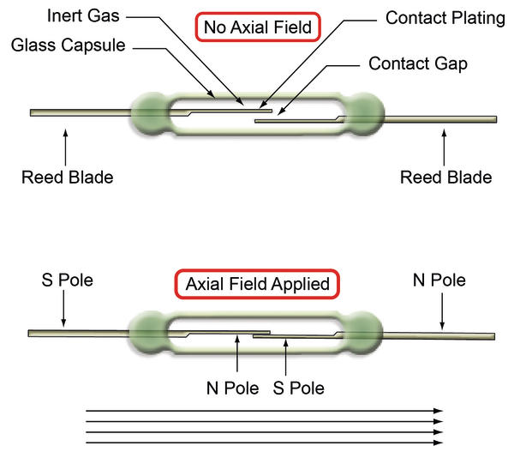

### Figure 4.10 REED RELAY-FIELD SENSOR

(Source: https://www.electronicdesign.com/21206307)

Figure 4.10 demonstrates reed relay field sensor. In theory, reed relays are deceptively simple devices. The reed switch consists of a package that houses two ferromagnetic metal blades of different shapes, typically nickel iron, and a glass envelope. The glass envelope securely holds the metal blades and creates a hermetic seal to protect the critical contact points from contaminants. The package also includes a coil for generating a magnetic field, a method for connecting the coil and reed switch externally, and an optional diode to handle any back EMF produced by the coil. In most cases, the contacts of the reed switch are normally open, although there may be exceptions. Overall, advancements in manufacturing technology have made the production of reed switches cost-effective.

A magnetic field applied along the reed blades' axis intensifies the field, attracts the open contacts between the blades, and causes the blades to deflect to close the gap because of the ferromagnetic nature of the blades. When a sufficient field is applied, the blades come into electrical contact with one another. The only moving part of the reed switch is the deflection of the blade; No materials are attempting to slide past pivot points or other materials. The reed switch is designed without any mechanical moving parts, ensuring that it does not experience mechanical wear. It is enclosed within a hermetically sealed envelope, which may contain inert gases or a vacuum in the case of high voltage switches. This protective enclosure shields the contact area from external contamination and greatly extends the mechanical lifespan of the reed switch.

**Applications**

* Device for monitoring current.
* Switch used for activating cupboard lights.
* Security alarm system integrated with Arduino.
* Alarm system to detect when a door is left partially open.

## 4.2.6 FLOATING SENSOR

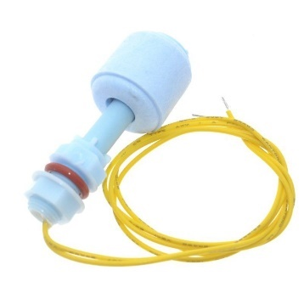

### Figure 4.11 FLOATING SENSOR

(https://www.gadgetronicx.com/interfacing-float-sensor-arduino/)

Figure 4.11indicates the floating sensor. The characteristics of the floating sensor are as follows

* A float switch measures the amount of fluid in a tank and may trigger different devices such as pumps, indicators, or alarms.
* When there is a change in the liquid level, the float switch either opens or closes a circuit. Typically, the float switch is designed to be "normally closed," meaning that the circuit is completed when the float is at its lowest position, resting on its bottom clip or stop. This configuration is commonly used when the tank is empty.
* The majority of float switches use a magnetic reed switch to open or close the circuit. A glass tube houses the reed and is epoxy-bonded to a plastic or stainless-steel stem. Moving a magnet closer or further away from a reed switch can be used to open or close a circuit, as shown in the diagram to the left.
* The two contacts draw together and touch as the magnet approaches, allowing current to flow. The contacts demagnetize and separate when the magnet is removed, breaking the circuit.
* In a float switch, a stem made of plastic or stainless steel is hermetically sealed inside the magnetic reed switch. A sealed magnet in the float moves up and down the stem as the fluid level changes.
* When a magnet passes by the enclosed contacts of a reed switch, it completes a circuit between the two lead wires.
* When used correctly, float switches are highly durable and can provide millions of on/off cycles for long-lasting and reliable performance. However, it's important to be cautious of overloading, which can lead to voltage spikes and potential failures. Before incorporating a float switch into a circuit, it is recommended to review the Technical Page on Spiking Voltage and Float Switches.

**Specifications**

* Maximum power handling capacity: 50 watts
* Maximum voltage for switching: 100 volts DC
* Minimum voltage for DC operation: 250 volts
* Switching current maximum: 0.5 amperes
* Current load maximum: 1 amperes
* Maximum contact resistance: 0.4 amperes

## 4.2.7 MQ2 Gas Sensor

Figure 4.12 shows the metal oxide semiconductor sensor is used in the MQ-2 smoke sensor. As a result, it is also known as a Chemi-resistor. The MQ2 sensor is capable of rapid detection of alcohol, propane, LPG, hydrogen, and methane. It operates at around 5V voltage and requires a warm-up period of 20 seconds. It can function as either a digital or analog sensor and is known for its compact size and user-friendly nature.

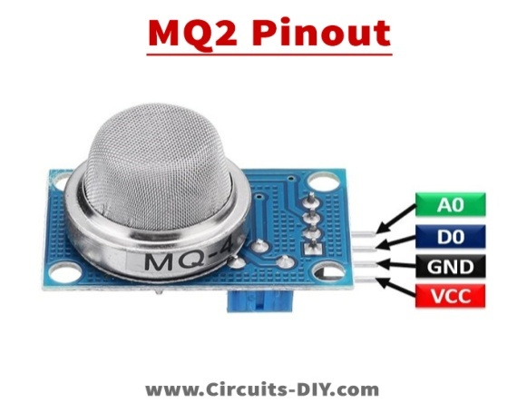

### Figure 4.12 MQ-2 Sensor

(Source: https://circuitdigest.com/microcontroller-projects/interfacing-mq2-gas-sensor-with-arduino)

# Table 4.4 Pin description of MQ-2 Sensor

|  |  |  |
| --- | --- | --- |
| Pin Name | Pin Number | Description |
| Vcc | 1 | Operating voltage for Power Pin is 5V. |
| GND | 2 | Ground pin. |
| DO | 3 | To get the sensor's digital output, digital out the pin. |
| AO | 4 | Pin analogue output. The output of this pin was dependant on the gas's intensity. |

**Working Principle of MQ-2**

MQ-2 sensor detects different types of gases by measuring the change in electrical resistance of the sensing element when the gas molecules interact with its surface. The change in resistance is measured and converted into an electrical signal, which is processed by the microcontroller to provide gas concentration information to the user. The sensor's sensitivity can be adjusted by varying the operating temperature and the bias voltage applied to the sensing element.

**Features of MQ-2 Sensor**

* Operates at a voltage of +5V and is capable of detecting a variety of gases including LPG, alcohol, propane, hydrogen, carbon monoxide, and methane.
* Provides analog output voltage ranging from 0 to 5V.
* Offers digital output voltage ranging from 0 to 5V in TTL logic.
* Requires a preheat time of 20 seconds before it is ready for operation.
* Serves as a versatile sensor that can be used in both digital and analog applications.
* The voltage regulator may be used to modify the digital pin's intensity.

## 4.2.8 HT12E RF ENCODER IC

Figure 4.13 shows an integrated circuit (IC) for remote control applications is the 212 series encoder, designated as the HT12E RF encode. Applications involving radio frequency (RF) are frequently used with it. Using the coupled HT12E encoder and HT12D decoder makes it simple to send and receive 12 bits of parallel data serially.

[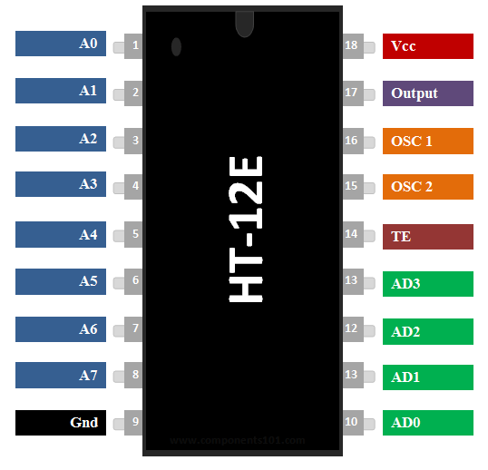](https://components101.com/sites/default/files/component_pin/HT12E-Pinout.png)

### Figure 4.13 Pinout diagram of HT12E RF ENCODER IC

(Source: https://sharvielectronics.com/product/ht12e-encoder-ic/)

**Features**

* The HT12D-compatible encoder IC is designed for 12-bit encoding.
* The encoded data consists of four data bits and eight address bits, totaling 12 bits.
* It is commonly utilized for wireless RF and IR transmission purposes.
* With a wide supply voltage range of 2.4V to 12V, 5V is the frequently used voltage.
* The IC has a low standby current of 0.1uA at Vcc=5V.
* It is available in two package options: 16-pin DIP and 20-pin SOP.

**Applications**

* Suitable for controlling short-range home automation applications through remote switching.
* Enables the conversion of parallel 4-bit data into serial data.
* Highly beneficial for wireless communication projects involving RF or IR technology.
* Utilized in remote-controlled systems such as garage doors, car alarm systems, and car door controls.
* Effective in safety systems including burglar alarm systems and smoke or fire alarm systems.

## 4.2.9 RF TRANSMITTER

[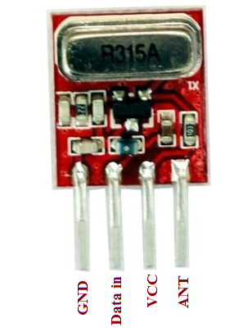](https://theorycircuit.com/wp-content/uploads/2015/12/ASK-434-Mhz.png)

### Figure 4.14 RF TRANSMITTER

(Source: http://elecclub.iiti.ac.in/)

Figure 4.14 shows Amplitude shift keying (ASK) transmitter and receiver at 434 MHz are used in the RF remote control circuit. This remote provides approximately 150-meter coverage, which can be increased to 200 metres by extending the ariel wire.

**Transmitter module parameter**

* Suitable operating voltage range: 3.5V to 12V.
* Compact dimensions: 19mm x 19mm.
* Utilizes AM (Amplitude Modulation) operating mode.
* Fast transfer rate: 4KB/s.
* Transmitting power: 10mW.
* Transmitting frequency: 315MHz.
* Requires an external antenna, preferably a regular multi-core or single-core line measuring 25cm.

## 4.3 Receiver

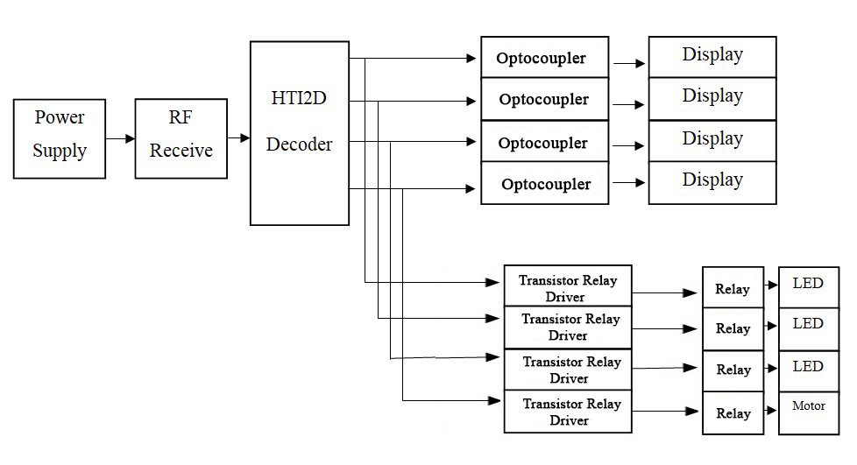

### Figure 4.15 Block diagram of Receiver

Figure 4.15 describes the blocks that are primarily involved in the proposed model's methodology. The following sections will provide a detailed description of the blocks.

## 4.3.1 RF RECEIVER MODULE

[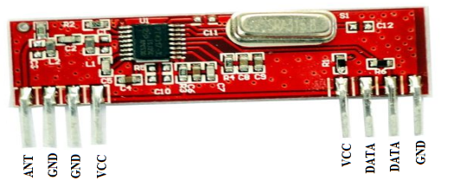](https://theorycircuit.com/wp-content/uploads/2015/12/433-ask-tx-rx.png)

### Figure 4.16 RF RECEIVER MODULE

(Source: http://elecclub.iiti.ac.in/)

Figure 4.16 shows the pin diagram of RF receiver module. When a 5V supply is applied to the circuit, all of the data lines are low, and the LEDs do not light up. When you press any switch from the Tx address, both the address and the data are transmitted. The serial data receiver at 433.92MHz demodulates the carrier and sends the address and data to IC HT12D.

**Receiver module parameters**

* Model: XY-MK-5V
* Suitable operating voltage: 5V DC
* Low quiescent current: 4mA
* Receiving frequency: 315MHz
* High receiver sensitivity: -105dB
* Compact dimensions: 30mm x 14mm x 7mm

## 4.3.2 HT12D RF Decoder IC

Figure 4.17 For remote control applications, Holtek produces the 212 series decoder IC (Integrated Circuit), known as the HT12D. It is widely used in wireless radio frequency (RF) applications. We are able to send 12 bits of parallel data serially when the HT12E encoder and HT12D decoder are used in tandem.

[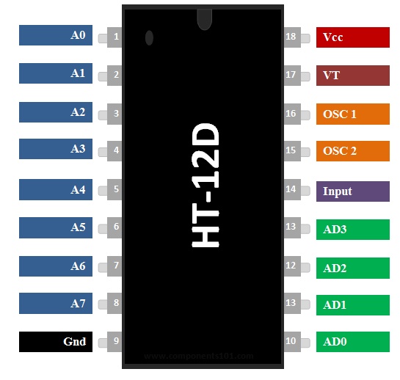](https://components101.com/sites/default/files/component_pin/HT12D-Pinout.png)

### Figure 4.17 Pinout diagram of RF decoder IC

(Source: https://components101.com/ics/ht12d-rf-decoder-ic)

**Features**

* The HT12D is a decoder IC designed to work with the HT12E.
* The decoded data consists of four data bits and eight address bits, totaling 12 bits.
* It is commonly used for wireless RF and IR transmission applications.
* The operating voltage is 5V.
* The standby current is very low, at 0.1uA when Vcc is set to 5V.
* The HT12D is available in 16-pin DIP and 20-pin SOP packages.

**Applications**

* The HT12D is employed for converting parallel 4-bit data into serial data.
* It is highly advantageous for wireless communication projects utilizing RF or IR technology.
* It finds extensive application in remote-controlled systems like garage doors, car alarm systems, car door controls, and more.

## 4.3.3 Relay module

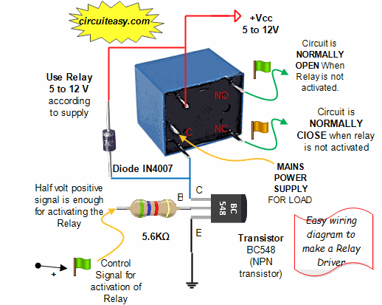

### Figure 4.18 Basic Relay Module

(Source: https://www.circuiteasy.com/what-is-a-relay-driver)

As shown in Figure 4.18, an electrical switch controlled by an electromagnet is known as a power relay module. The electromagnet is turned on by a separate, low-power signal from a microcontroller. An electrical circuit can be opened or closed by the electromagnet when it is turned on.

**Circuit:**

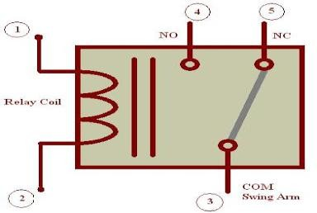s

### Figure 4.19 Circuit Diagram of Relay Module

(Source: https://www.circuiteasy.com/what-is-a-relay-driver)

A relay is a switch powered by electricity, as depicted in Figure 4.19. When current flows through the relay coil, it creates a magnetic field, attracting a lever and altering the switch contacts. Due to the fact that the coil current can be either on or off, most relays have double-throw (changeover) switch contacts. Relays have two switch positions. Relays make it possible for one circuit to switch to another circuit that is completely separate from the first.

## 4.3.4 Transistor Relay Driver

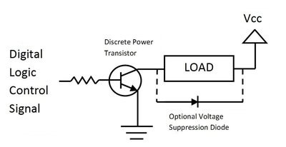

### Figure 4.20 Circuit Diagram of Transistor Relay Driver

(https://os.mbed.com/media/uploads/4180_1/_scaled_driverbjt.jpg)

A transistor Relay driver circuit is shown in Fig 4.20. The output pins of a typical digital logic circuit can only provide limited current in the range of tens of milliamps. However, although requiring identical voltage levels, certain external devices, such as high-power LEDs, motors, speakers, light bulbs, buzzers, solenoids, and relays, may need hundreds of milliamps or even several amps of current.

# Chapter 5

# Results

The Hardware model has been developed and tested. The transmitter module consists of wide range of sensors for detecting parameters such as gas, heat, field, and liquid levels. Similarly, the receiver module consists of display for indicating the above parameters and relay modules to connect the devices. The communication is carried by using RF module. The developed hardware worked properly and produced satisfactory results.

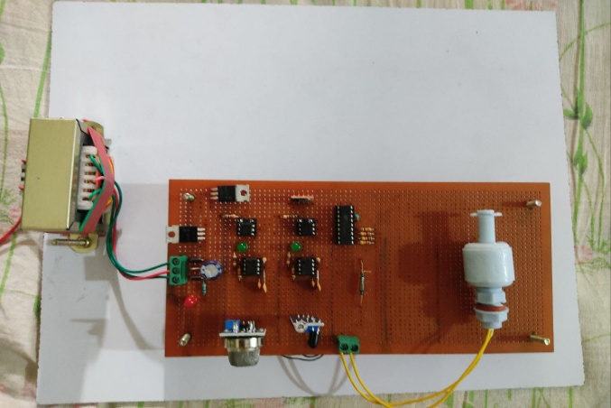

### Figure 5.1 Transmitter Circuit

Figure 5.1 shows the transmitter module having different sensors such as heat sensor, oil sensor, MQ-2 sensor, Reed Relay Field sensor, and components like optocoupler, RF transmitter, encoder, and a power supply unit.

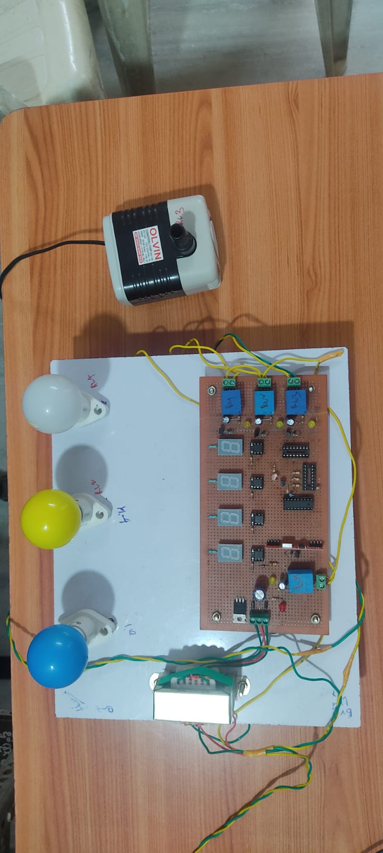

### Figure 5.2: Receiver Circuit

Figure 5.2 shows the receiver module having displays for indicating status of sensors, relay drivers, RF receiver module, decoder and appliances like lights and a motor.

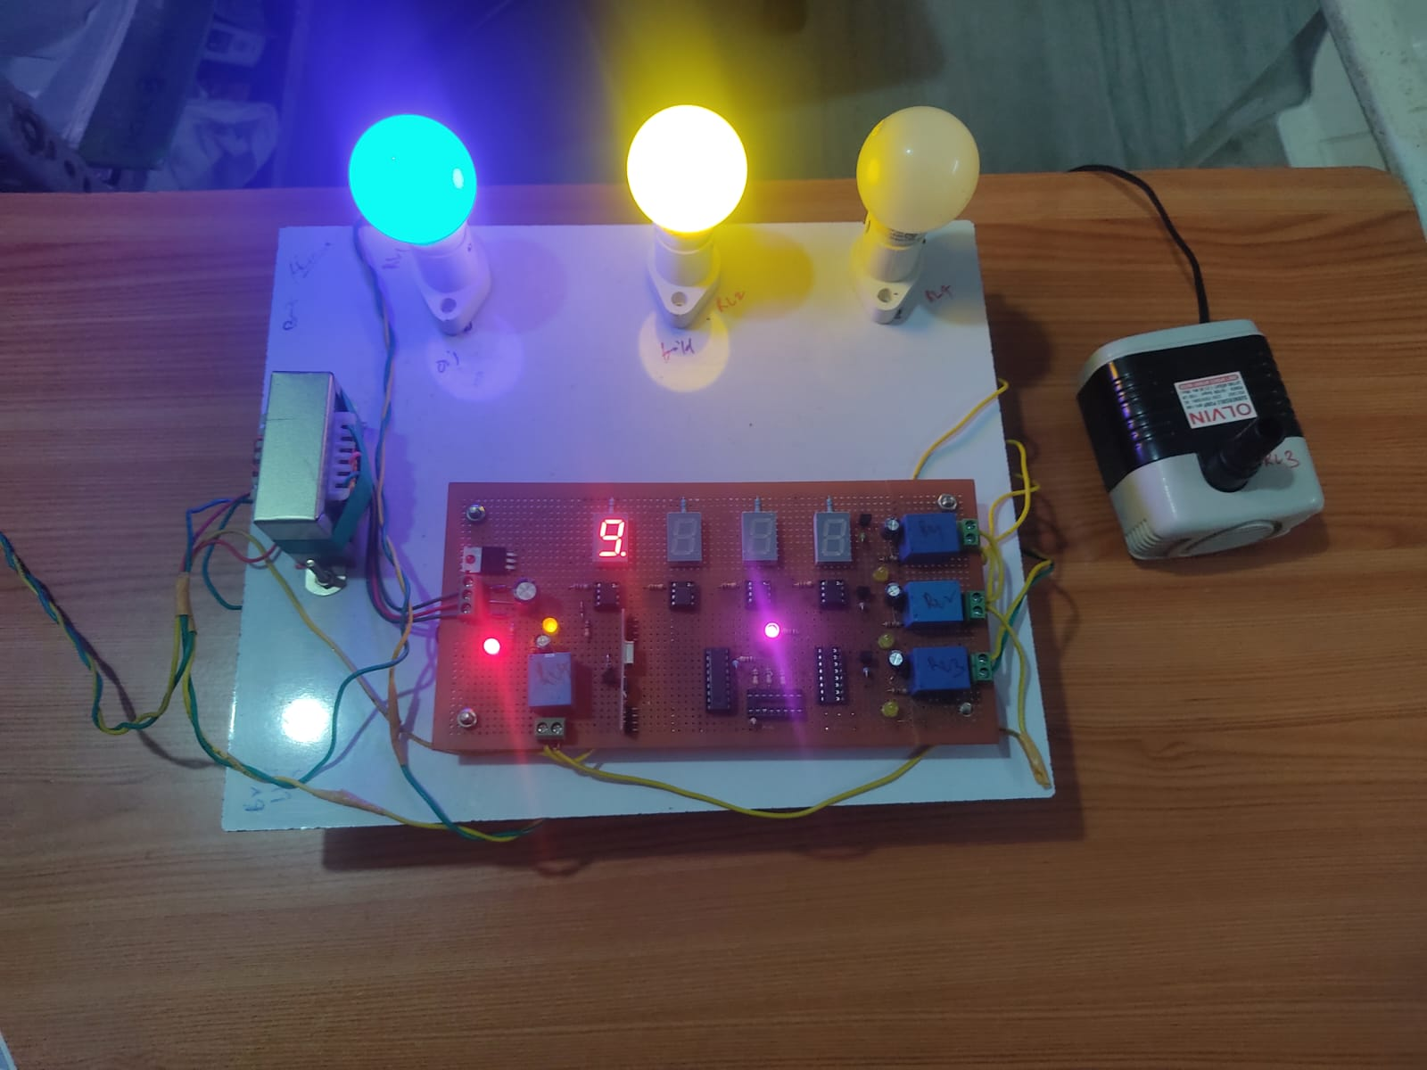

### Figure 5.3: Gas Detection

Figure 5.3 describes the operation of detecting gases like propane, LPG, hydrogen, and methane. When the MQ-2 sensor in the transmitter detects a gas leakage then the display in the receiver module indicates letter **‘g’** with an alarm thereby switching the bulb to off state .

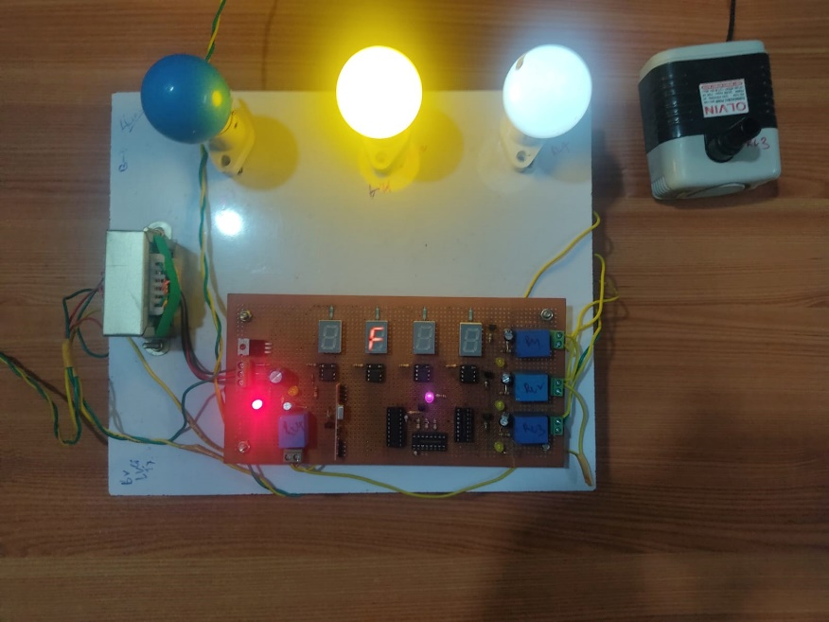

### Figure 5.4 Magnetic Field

Figure 5.4 depicts the operation of detecting magnetic field. When the Reed relay sensor in the transmitter detects a field then the display in the receiver module indicates letter **‘f’** with an alarm thereby switching the bulb to off state.

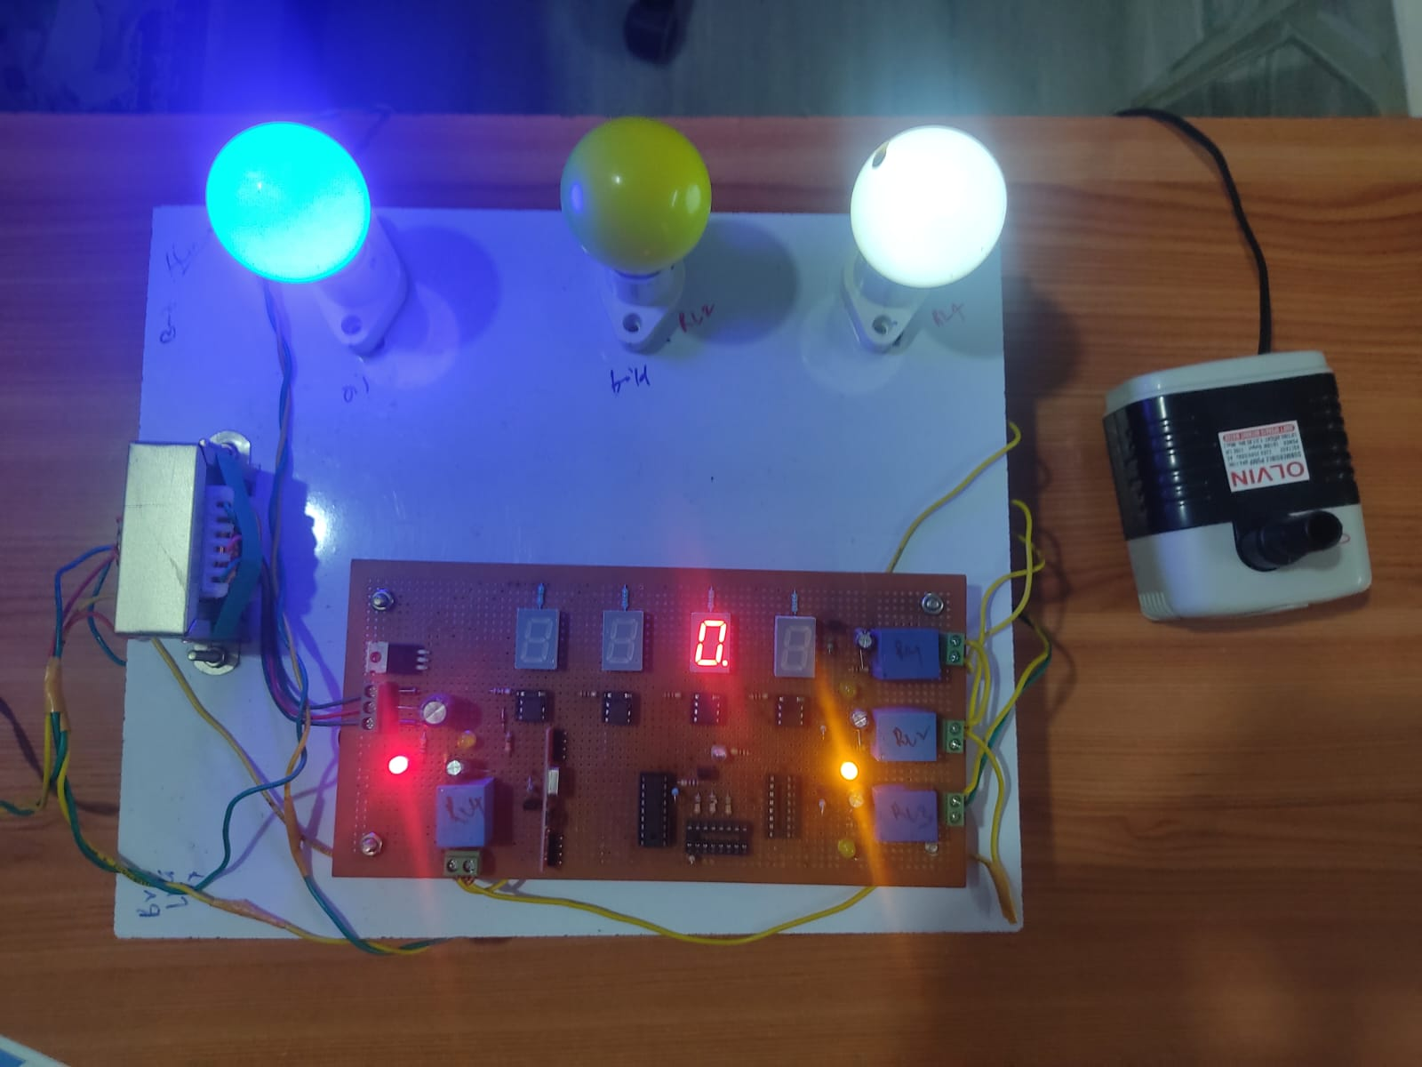

### Figure 5.5 Oil Detection

Figure 5.5 illustrates the operation of detecting a change in liquid levels. When the floating sensor in the transmitter detects a field then the display in the receiver module indicates letter **‘o’** with a buzzer sound thereby switching the bulb to off state.

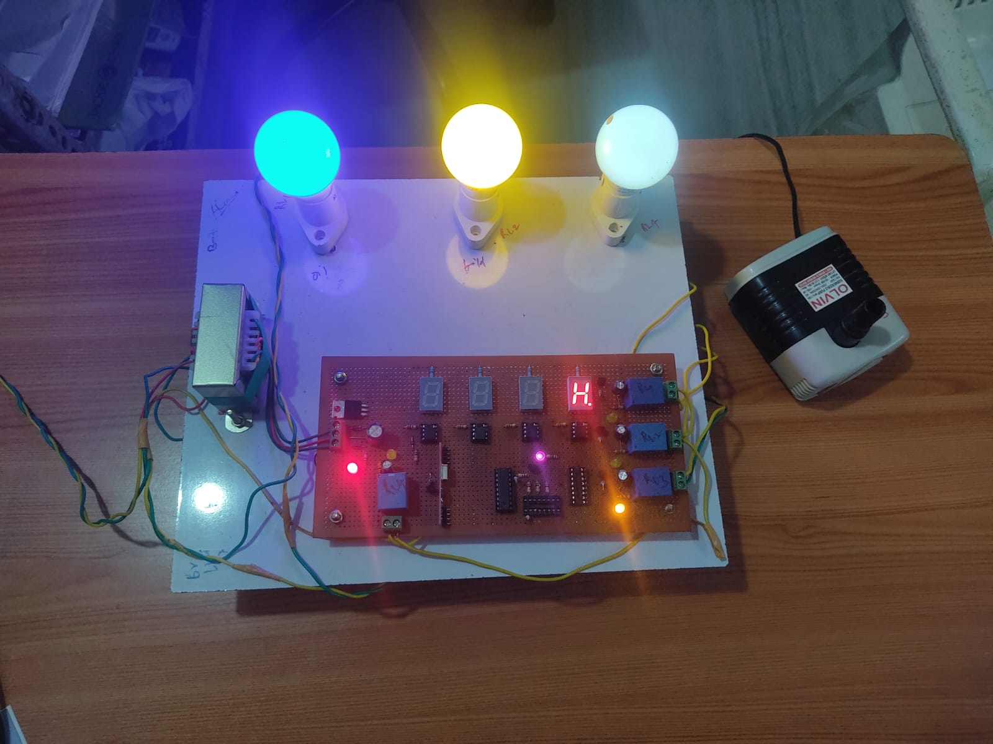

### Figure 5.6 Heat Detection

Figure 5.6 describes the operation of detecting fire. When the flame sensor in the transmitter detects fire then the display in the receiver module indicates letter **‘h’** with a buzzer sound and switches motor automatically.

# Chapter 6

# Conclusion and Future Scope

## 6.1 Conclusion

By the realization of the above-proposed system, we have successfully implemented a prototype that could detect gas concentration, level of liquids, field effects and, level of liquid. The real-time data from various sensors is displayed by use of wireless technology more efficiently and can improve safety systems in the industry. Furthermore, this research paper presents an enhanced approach for controlling industrial machinery and monitoring the industrial environment to enhance product quality. It outlines the utilization of wireless sensor networks for automation and monitoring tasks, offering potential benefits such as cost reduction and improved maintenance of industrial environment automation and safety in the future.

## 6.2 Future Scope

The future goal of this project will be to implement more sensors and control large number of parameters to improve the efficiency and safety of industrial automation. Furthermore, future enhancements will include bi-directional data transmission and aiding in the further development of bi-directional communication between devices and remote areas. A user should be able to operate the data in full duplex mode, that is, transmitting and receiving simultaneously. Data can be broadcasted, and data sent can reach multiple recipients even when using different system technologies.

# References

[1] H. Ramamurthy, B. S. Prabhu, R. Gadh and A. M. Madni, "Smart sensor platform for industrial monitoring and control," SENSORS, 2005 IEEE, Irvine, CA, USA, 2005, pp. 4 pp.-, doi: 10.1109/ICSENS.2005.1597900.

[2] P. V. Shekdar, S. R. Hirekhan, 2012, Implementation of Wireless Smart Sensor Platform for Industrial Application, INTERNATIONAL JOURNAL OF ENGINEERING RESEARCH & TECHNOLOGY (IJERT) Volume 01, Issue 03 (May 2012),

[3] Ramamurthy, H., Prabhu, B. S., Gadh, R., & Madni, A. M. (2007). Wireless Industrial Monitoring and Control Using a Smart Sensor Platform. IEEE Sensors Journal, 7(5), 611–618. https://doi.org/10.1109/JSEN.2007.894135

[4] S. R. Khan and M. S. Bhat, "GUI based industrial monitoring and control system," 2014 POWER AND ENERGY SYSTEMS: TOWARDS SUSTAINABLE ENERGY, Bangalore, India, 2014, pp. 1-4, doi: 10.1109/PESTSE.2014.6805278.

[5] P. Karemore and P. P. Jagtap, "A Review of IoT Based Smart Industrial System for Controlling and Monitoring," 2020 Fourth International Conference on Computing Methodologies and Communication (ICCMC), Erode, India, 2020, pp. 67-69, doi: 10.1109/ICCMC48092.2020.ICCMC-00012.

[6] Aishwarya Khandekar, Meenakshi Basvankar, Alfarin Sayed, 2017, Industrial Automation using Microcontroller, INTERNATIONAL JOURNAL OF ENGINEERING RESEARCH & TECHNOLOGY (IJERT) ICIATE – 2017 (Volume 5 – Issue 01),

[7] B. Razavi, "RF transmitter architectures and circuits," Proceedings of the IEEE 1999 Custom Integrated Circuits Conference (Cat. No.99CH36327), San Diego, CA, USA, 1999, pp. 197-204, doi: 10.1109/CICC.1999.777273.

[8] T. Ramachandran, S. Kumar, A. Kumar, and R. Agarwal, "Radio Frequency Based (RF) Control & Operation of Electrical/Electronic Appliances in Home/Offices," 2018 2nd IEEE International Conference on Power Electronics, Intelligent Control and Energy Systems (ICPEICES), Delhi, India, 2018, pp. 1232-1236, doi: 10.1109/ICPEICES.2018.8897390.